A data frame with 463 observations on the following 23 variables.

**ID_course**

**Id_prof**

**score**

Avg evaluation score of professor: (1) highly unsatisfactory - (5) excellent.

**Prof_rank**

Prof rank: teaching, tenure track, tenured.

**ethnicity**

Prof Ethinicity: not minority, minority.

**gender**

Prof gender: female, male.

**language**

Education language of prof: English or non-English.

**age**

Prof age.

**Eval_completed_perc**

Percentage of students in class - completed evaluation.

**No_completed_eval**

Number of students in class- completed evaluation.

**Total_no_students**

Total number of students - class.

**Level_class**

Class level: lower, upper.

**Class_of_profs**

No of professors who teach sections in course in sample: single, multiple.

**class_credits**

No of credits of class: one credit (lab, PE, etc.), multi credit.

**beauty_f1lower**

Beauty rating of prof of female lower level: (1) lowest - (10) highest.

**beauty_f1upper**

Beauty rating of prof of female upper level: (1) lowest - (10) highest.

**beauty_f2upper**

Beauty rating of prof of female second level: (1) lowest - (10) highest.

**beauty_m1lower**

Beauty rating of prof of male lower level: (1) lowest - (10) highest.

**beauty_m1upper**

Beauty rating of prof of male upper level : (1) lowest - (10) highest.

**beauty_m2upper**

Beauty rating of prof of male second upper level: (1) lowest - (10) highest.

**beauty_avg**

Average beauty rating of professor.

**picture_outfit**

Professoroutfit in picture: not formal, formal.

**picture_color**

Professor's picture Color: color, black & white.

1. The evaluation score for the professors has been got from the students. The scores are generated based on the looks of the Professor.

1.a Make **a histogram and identify the distribution of the scores.**

**1.b What do you infer from the distribution?**

1. It is assumed that good looking professors have better scores.

2.a Make a **plot to see the relation between the scores and the average beauty values**.

2.b What do you infer from this plot?

1. Fit a linear model to this plot and list out the coefficients (intercept and slope).
2. 4.aFrom this model what do you infer from the slope.

4.b Does the average beauty rating make a significant predictor variable?

1. Multiple Linear Regression
2. **6.a Identify the co-relation between the average beauty value and b_f1upper**.

6.b What do you infer from this

1. a. Also identify the co-relation between the following attributes

**beauty_f1lower,beauty_f1upper,beauty_f2upper,beauty_m1lower,beauty_m1upper,beauty_m2upper,beauty_avg**

1. What do you infer from the co-relation that arrives from Q7
2. Based on removing the multicollinearity Make a multilinear model that fits
3. Write the final model obtained.
4. List out the standard error for each attribute above and write down what you infer from that

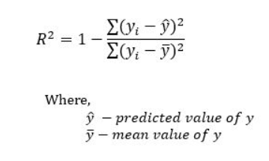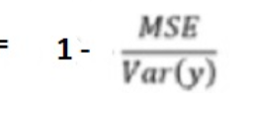

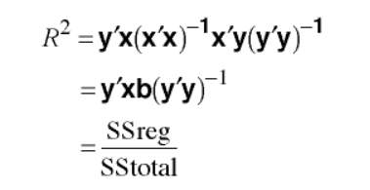

Std error -Use the **standard error of the coefficient to measure the precision of the estimate of the coefficient**. The **smaller** the standard error, the more precise the estimate. **Dividing the coefficient by its standard error** calculates a t-value. If the p-value associated with this t-statistic is less than your alpha level, you conclude that the coefficient is significantly different from zero.

1. On analysing the MSE and R2 error what do you infer from the values